System Documentation

A.

Good Human-Computer Interaction (HCI) design can enhance the usability and accessibility of the Legend Motor Vehicle System,  improving user satisfaction. By applying key HCI principles, the system provides a clear content presentation and efficient task execution. For example, simplifying the registration, login, and reset password process reduces cognitive load, enabling users to access vehicle browsing more easily.

A well-organized user interface aligns with users' mental models, making interactions consistent. Affordance, such as clearly labeled buttons and input fields, ensures that users understand how to perform actions like adding items to their wishlist or confirming purchases and mouse over the navigation bar to show related items. Intuitive icons can make users easier to use without instructions. For example, a shopping cart icon means the user's wishlist and a user icon means the user can click it to login or look at their information. The system using black and white colors can give users a trendy experience. These designs can increase user satisfaction based on the system usability and simplicity. The system is beginner-friendly, enabling first-time users to navigate and learn it easily.

By incorporating error prevention mechanisms, such as real-time validation during form inputs, the system minimizes frustration caused by incorrect data entry. Providing feedback after each action (e.g., a confirmation message after a purchase) builds trust and confidence in the system.

Ultimately, a strong focus on HCI principles creates a system that is user-friendly, efficient, and accessible, fostering customer loyalty and enhancing the overall sales experience for Legend Motor Limited.

B.

**User Characteristics**

1. **Customers**:
   * Age range: 25–55 years.
   * Technological familiarity: Moderate (frequent internet and mobile device users).
   * Primary goals: Browse vehicles, purchase vehicles, and request insurance quotes.
2. **Vehicle Sales Personnel**:
   * Age range: 30–50 years.
   * Technological familiarity: High (regular use of CRM systems and sales tools).
   * Primary goals: Manage customer orders, track statuses, and communicate with customers.
3. **Insurance Sales Personnel**:
   * Age range: 30–50 years.
   * Technological familiarity: High (familiarity with policy generation tools and customer interaction platforms).
   * Primary goals: Process insurance requests, generate quotes, and respond to inquiries.

**Techniques for Observing and Listening to Users**

* **Surveys**: Gather user preferences and expectations for online vehicle purchasing and insurance quoting.
* **Interviews**: Conduct one-on-one interviews with sales personnel to understand their workflow and pain points.
* **User Testing**: Create prototypes and observe user interactions to identify challenges and areas for improvement.

**Environment Analysis**

* **Customers**: Primarily interact with the system from their homes or offices using laptops or desktops.
* **Sales Personnel**: Use the system in office environments or during field visits via tablets or desktops.

#### ****Recruiting Users****

1. **Customers**:
   * Use existing customer data to send invitations for surveys and usability testing.
   * Incentivize participation with discounts or gift cards.
2. **Sales and Insurance Personnel**:
   * Involve internal employees during system design and testing phases to ensure alignment with workflows.

#### ****Hierarchical Task Analysis (HTA)****

##### **Primary Task: Ordering a Car**

1. **Select a Car Model**:
   * View available models.
   * Choose a specific model.
2. **Submit the Order**:
   * Add personal details.
   * Confirm purchase and make payment.

##### **Sales Personnel Handling Orders**

1. **View New Orders**:
   * Access the list of pending orders.
2. **Update Order Status**:
   * Mark orders as “Processing,” Cancel” or “Completed.”
3. **Communicate with Customers**:
   * Notify customers of status updates via email.

##### **Insurance Sales Workflow**

1. **Review Insurance Request**:
   * Access insurance details submitted by customers.
2. **Generate and Send Quotes**:
   * Calculate insurance premium based on car model and features.
3. **Confirm Insurance**:
   * Finalize insurance policies and update system records.

#### ****Example HTA for Primary Task****

**1. Ordering a Car**  
**1.1** Select a Car Model  
**1.2** Submit the Order  
    **1.2.2** Enter delivery address and credit card information.

**1.2.3** Confirm purchase

C

Mental Model

Mental models are critical to ensuring that users intuitively understand how to interact with the system. The design incorporates familiar metaphors and UI patterns:

Example: A shopping cart icon is used for vehicle selections, resembling online retail platforms. Users instinctively understand this as the place to review selected items before finalizing their purchase.

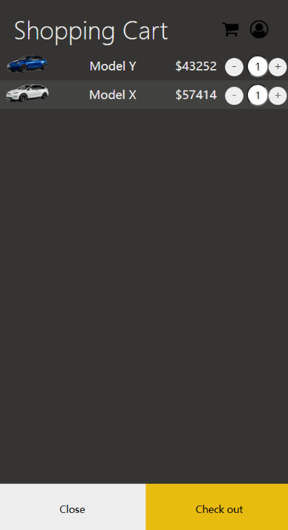

The system aligns with users' expectations by presenting familiar patterns, such as a shopping cart for vehicle selections and a navigation menu for exploring sections (e.g., Vehicles).

Users can predict interactions, such as hovering over menu items to reveal subcategories or clicking buttons to perform actions like adding a car to the wishlist.

Example: When the user hovers over the drop dropdown menu, and it will have a shadow underline the word and show the related item, helping the user explore the website.



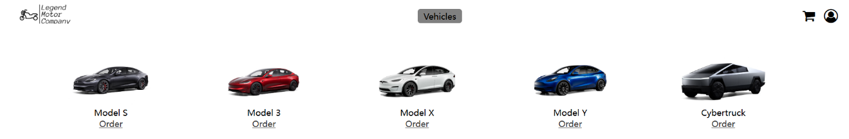

Affordance

Buttons, dropdowns, and input fields are styled to clearly indicate interactivity.

Example: The "Add to Cart" button is designed with rounded corners, a shadow effect, and a hover state (changing color to green) to visually invite users to click.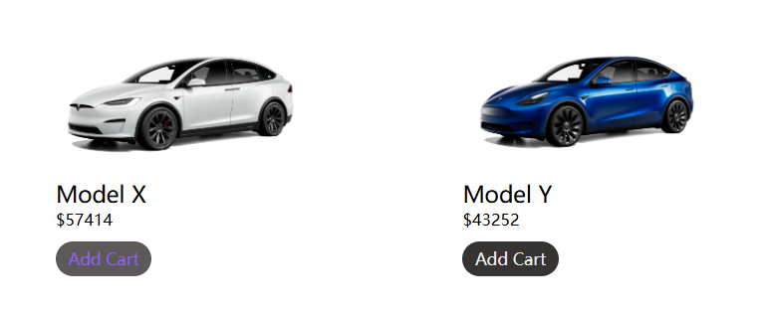

When the user clicks or enters the input placeholder, it will move to the top of the box, and the border will be blue to announce to the user what column the information it should enter.

Before:



After:

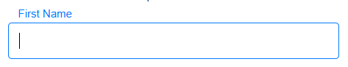

Icons (e.g., shopping cart, user profile) convey their purpose intuitively without requiring explanations.



Content Organization

Information is hierarchically structured to minimize cognitive load. Users first have the choice of login this is filtering the user action.

Example: On the login page user can choose to sign in, reset the password, or create a brand new account. If the user wants to login user can enter the email they registered and then, move to the next page and enter their password. On the password page, user can not change their email unless they click the “Change” and go back to the login page.

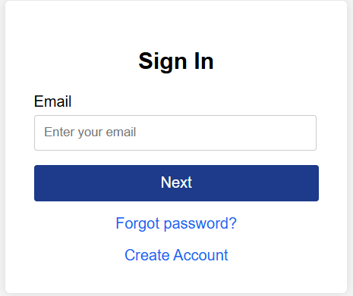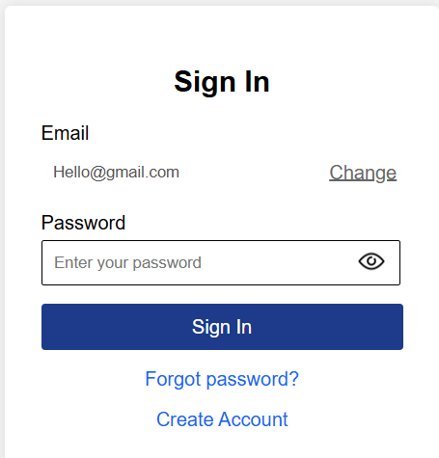

Example: The homepage highlights featured vehicles and insurance offers at the top, while less critical sections (e.g., Terms and Conditions) are positioned in the footer.

**Visual Organization**

* A grid layout ensures content is aligned, reducing visual clutter. Flexbox and CSS Grid are used to position elements evenly across the page.
* White space is strategically employed to separate sections, making the interface clean and easy to read.
* Example: On the salesperson page, the order management status uses different colors to show the order status to help the salesperson manage and recognize the order. The alignment of the page user can clearly see each order on the page.

